Business Requirement Document – AI-based Project & Scheme Appraisal System for DoE

1.1 Introduction
The Department of Expenditure (DoE) plays a critical role in appraising Central Sector and Centrally Sponsored Schemes before financial concurrence. Currently, the appraisal process involves manual scrutiny, experience-driven intuition, and reference to multiple unstructured information sources, including Office Memorandums (OMs), appraisal guidelines, budget data, evaluation studies, research literature, and inter-departmental concurrence notes.
With the increasing volume, complexity, and inter-ministerial convergence of schemes, the existing appraisal mechanism faces challenges related to consistency, traceability, turnaround time, and institutional memory.
This BRD proposes an AI-enabled Project & Scheme Appraisal System that assists DoE officials throughout the end-to-end lifecycle of scheme appraisal, starting from receipt of DPRs on eOffice to final appraisal recommendations, while remaining fully compliant with DoE OMs and established appraisal practices.

2. Objectives
The key objectives of the proposed system are:
- To augment (not replace) human appraisal by providing AI-assisted insights
- To standardize appraisal against DoE OMs, circulars, and appraisal guidelines
- To enable automated scheme convergence checks across ministries and departments
- To support evidence-backed decision making using structured and unstructured data
- To reduce appraisal timelines while improving auditability and transparency
- To institutionalize tribal knowledge and intuition-based assessments
- To ensure seamless integration with PFMS, UBIS, and allied data sources

3. Stakeholders
S.no. | Stakeholder Type | Stakeholder
1. | Department of Expenditure (DoE) | Department of Expenditure (DoE)
2. | Department of Expenditure (DoE) | Section Officers (SO)
3. | Department of Expenditure (DoE) | Under Secretaries / Directors
4. | Department of Expenditure (DoE) | Joint Secretaries
5. | Department of Expenditure (DoE) | Integrated Finance Division (IFD)
6. | Secondary Stakeholders | Financial Advisors (FA) of Line Ministries
7. | Department of Expenditure (DoE) | Nodal Divisions within DoE
8. | Department of Expenditure (DoE) | Budget Division (for UBIS data)
9. | Department of Expenditure (DoE) | Appraisal Committees

4. Business Process Workflow
High-Level Workflow
- DPR received on eOffice and assigned to DoE Section Officer
- AI ingests DPR and maps it to relevant scheme category and sector
- Automated and assisted checks triggered:
  - Scheme convergence
  - OM compliance
  - Budget sustainability
  - Evidence & evaluation references
- AI-generated appraisal insights presented to SO
- SO performs review, applies judgment, and records observations
- Appraisal note drafted with AI assistance
- File moves through hierarchical approval

Indicative Functional Flow:
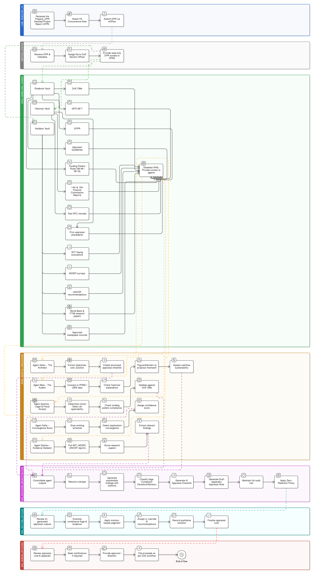

5. User Journey (Section Officer – Primary User)
- SO receives DPR file link from eOffice
- Opens AI Appraisal Dashboard
- Views:
  - DPR summary
  - Applicable OMs & circulars
  - Compliance score & gaps
- Reviews AI findings on:
  - Scheme convergence
  - Budget availability
  - Prior evaluations
- Adds manual notes, intuition-based remarks
- Generates draft appraisal checklist & note
- Submits for senior review

6. Functional Requirements

S.no. | Functional Requirement | Activity
1. | FR-1: DPR Ingestion & Understanding | - Upload / fetch DPR from eOffice  - AI-based summarization and classification
2. | FR-2: Scheme Convergence Analysis | - Detect overlap with:  - Existing schemes  - Similar sectoral interventions  - Indicate:  - Manual vs automated confidence  - Source references
3. | FR-3: OM & Circular Compliance Engine | 1. Map DPR content to:  - DoE OMs  - Appraisal guidelines  2. Highlight deviations and missing elements
4. | FR-4: Budget Sustainability Assessment | - Integrate with UBIS via PFMS  - Assess:  - Cash flow sufficiency  - GDP allocation alignment  - Medium-term expenditure impact
5. | FR-5: Evidence & Knowledge Aggregation | Auto-fetch and rank:  - NITI Aayog studies  - Evaluation reports  - MOSPI surveys  - UNICEF recommendations  - Research papers (based on impact factor, H-index, citations)  - Newspaper articles (configurable sources)
6. | FR-6: Intuition & Expert Judgment Capture | Allow SO to:  - Record qualitative assessments  - Override AI suggestions with justification
7. | FR-7: Checklist & Appraisal Note Generation | - Auto-generate:  - Appraisal checklist  - Structured appraisal note  - Editable by officers

7. Non-Functional Requirements
- Explainability: Every AI flag must cite source OM / report
- Security: Zero data retention post-processing
- Data Sovereignty: India-only data processing
- Audit Trail: Every AI suggestion & human override logged
- Configurability: OMs updatable without retraining

8. Business Rules / Logic
  - APAS outputs are advisory only
  - Human override always prevails
  - Only digitised, approved rules are enforced
  - Convergence alerts do not auto-reject proposals
  - Research credibility follows predefined weightage
  - Budget flags indicate risk, not disqualification

